
LESSON NOTE | DETAILED EXPLANATORY NOTES
ECOLOGY & EVOLUTION
THEORIES OF EVOLUTION - DARWIN vs LAMARCK
GRADE 12 - BIOLOGY
■ ■ ■

Explaining How Species Change
Evolution is the change in the inherited features of a population of living things over many generations. For a long time, people wondered how species come to be so well suited to their environments, and how new species arise. Two scientists offered famous explanations: Jean-Baptiste Lamarck and Charles Darwin. Both agreed that species change over time, but they disagreed sharply about how - and only one of their ideas has stood the test of evidence.
This lesson compares the two theories, using the classic example of the giraffe's long neck. It explains Lamarck's idea of the inheritance of acquired characteristics, Darwin's idea of natural selection, why Darwin's theory is accepted today, and what this means for understanding life. It is a central topic in the Ecology & Evolution strand.
Why This Matters
- Evolution explains the diversity of life and how species change.
- Comparing the theories shows how science tests and improves ideas.
- Darwin's natural selection is a foundation of modern biology.
- It underpins medicine, agriculture and conservation.
Theories of Evolution (Darwin vs Lamarck)
Key Learning Outcomes
By the end of this lesson, students should be able to:
- Define evolution and state that species change over time.
- Explain Lamarck's theory (inheritance of acquired characteristics).
- Explain Darwin's theory of natural selection.
- Compare the two theories using the giraffe example.
- Explain why Darwin's theory is accepted and Lamarck's is not.
Lamarck's Theory
Lamarck (about 1809) proposed the inheritance of acquired characteristics. He suggested that a body part becomes stronger or larger with use and weaker with disuse, and that these changes gained during an organism's lifetime could be passed on to its offspring. For the giraffe, Lamarck argued that an ancestor stretched its neck to reach high leaves, its neck grew longer during its life, and it passed this longer neck to its young - and so, over generations, giraffes came to have long necks. This idea seems reasonable but is now known to be incorrect.
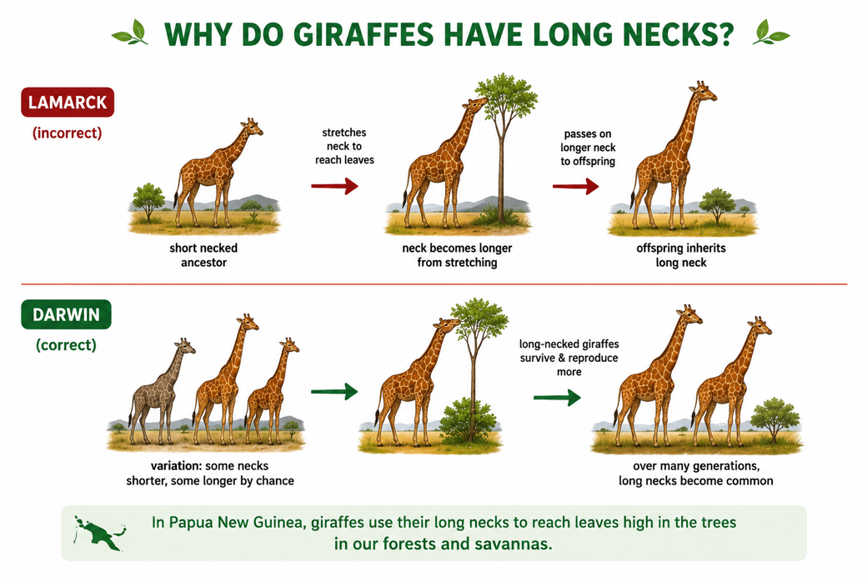
Figure 1: Lamarck vs Darwin - two explanations for the giraffe's long neck.
Terminologies and Concepts
Useful terms for this topic:
- Evolution: change in inherited features of a population over generations.
- Acquired characteristic: a feature gained during an organism's lifetime.
- Inheritance of acquired characteristics: Lamarck's (incorrect) idea.
- Variation: natural differences between individuals in a population.
- Natural selection: the survival and reproduction of the best-suited individuals.
- Adaptation: an inherited feature that improves survival.
- Fitness: an organism's ability to survive and reproduce.
Why Lamarck Was Wrong
Lamarck's theory fails because characteristics acquired during life are not inherited. Changes to the body of an organism - bigger muscles from exercise, a stretched neck, a lost limb - do not change the genes in its sex cells (gametes), so they cannot be passed on. A weightlifter's children are not born with big muscles. Only features coded in the DNA of the gametes are inherited. Because Lamarck's mechanism has no way to change what is passed to offspring, it does not explain evolution.
Darwin's Theory - Natural Selection
Charles Darwin (1859) explained evolution by natural selection. He observed that individuals in a population naturally vary, and that this variation is inherited. More offspring are produced than can survive, so there is a struggle for existence. Individuals with variations that make them better suited to the environment are more likely to survive and reproduce - 'survival of the fittest'. They pass their helpful variations to their offspring, so over many generations these features become more common. For the giraffe: some giraffes were born with longer necks; in times of food shortage, the long-necked ones reached more leaves, survived and reproduced, so long necks gradually became typical.
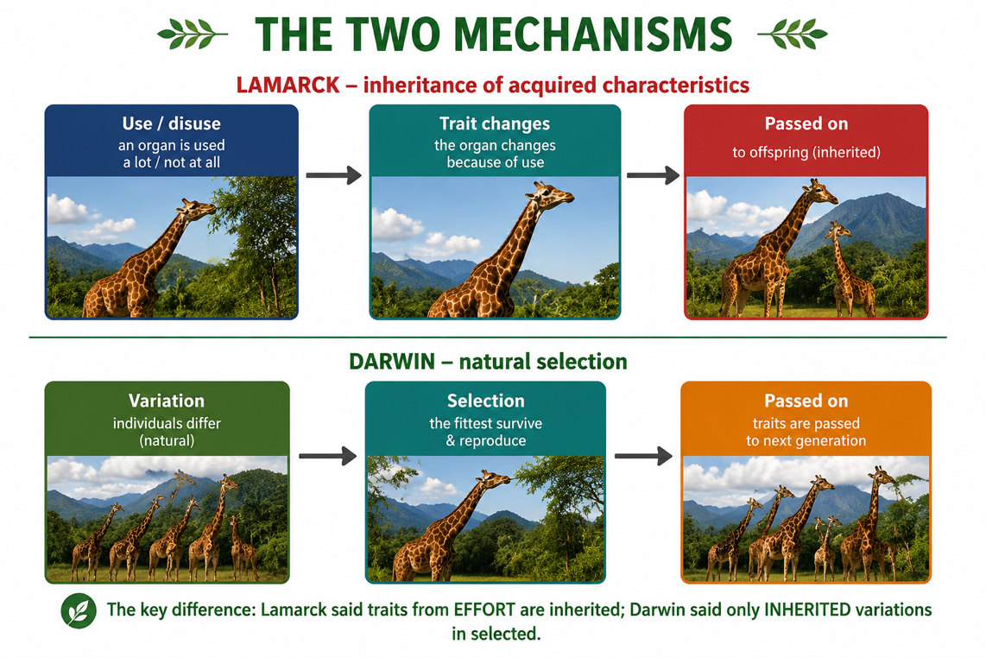
Figure 2: The two mechanisms - Lamarck's inheritance of acquired traits, and Darwin's natural selection.
Comparing the Two Theories
The two theories differ in where the change comes from and what is inherited. In Lamarck's theory, change comes from the organism's own effort and use of body parts, and these acquired changes are inherited. In Darwin's theory, change comes from inherited variation that already exists in the population, and the environment selects which variations survive. The crucial difference is that Darwin's mechanism works on inherited variation, while Lamarck's relies on non-inheritable, acquired changes. Modern genetics the discovery of DNA and how it is passed on - confirms Darwin and rules out Lamarck.
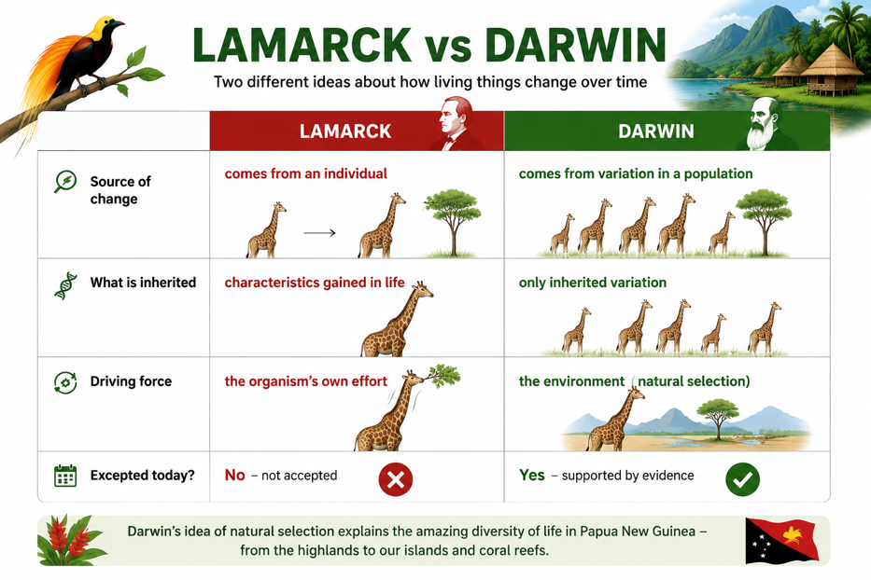
Figure 3: A comparison of Lamarck's and Darwin's theories of evolution.
Why This Matters
- Understanding life - natural selection explains the diversity and fit of living things.
- Nature of science - it shows how evidence decides between competing ideas.
- Medicine - natural selection explains antibiotic resistance in bacteria.
- Agriculture - selective breeding applies the same principles deliberately.
PNG Context Example
Darwin's ideas help explain the astonishing life of Papua New Guinea. The many species of birds of paradise, each with different plumage and displays, are a striking result of natural (and sexual) selection acting over long periods in isolated habitats. PNG's islands and rugged mountains have separated populations, allowing natural selection to shape them into distinct forms - a living example of evolution. Understanding natural selection also has practical value: it explains why malaria parasites and bacteria can become resistant to drugs, guiding better health treatment. Darwin himself drew on nearby regions like New Guinea and Australia in developing his theory.
References & Related Documents
Source Documents
- Biology Standards-Based Syllabus, Grades 11 & 12 (PNG SBC 2020) - Strand: Ecology & Evolution; compare theories of evolution (Lamarck and Darwin) and explain natural selection.
- STEM Biology Syllabus - Grade 12. Thema: Evolution; Module: Theories of Evolution. Department of Education, PNG.
Further Reading & References
- OpenStax Biology - Understanding Evolution; Darwin and Natural Selection. https://openstax.org/books/biology
- Khan Academy - Darwin, evolution, and natural selection. https://www.khanacademy.org/science/biology/her

